Question 1 .
Exercise (Author and Book): Create a class called Author is designed as follows:
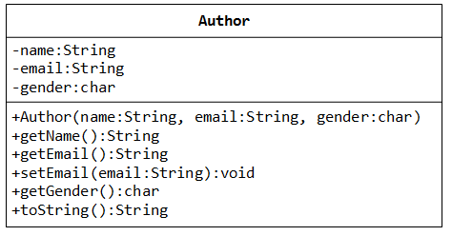
It contains:
- Three private instance variables: name (String), email (String), and gender (char of either ‘m’ or ‘f’);
- One constructor to initialize the name, email and gender with the given values;
- Getters and setters: getName(), getEmail() and getGender(). There is no setters for name and gender because these attributes cannot be changed.
Write the Author class. Also write a test program called TestAuthor to test the Author constructor and call the public methods of the Author class. (including toString() method)
Author anAuthor = new Author(“Tan Ah Teck”, “ahteck@somewhere.com”, ‘m’);
And, a class called Book is designed as follows:
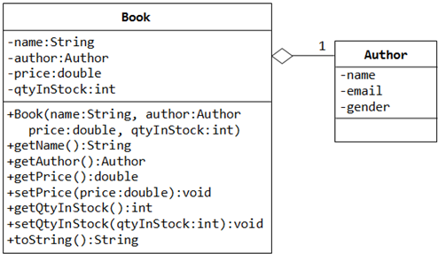
It contains:
- Four private instance variables: name (String), author (of the class Author you have just created), price (double), and qtyInStock (int). Assuming that each book is written by one author.
- One constructor which constructs an instance with the values given.
- Getters and setters: getName(), getAuthor(), getPrice(), setPrice(), getQtyInStock(), setQtyInStock(). Again there is no setter for name and author.
Write the class Book (which uses the Author class written earlier). Also write a test program called TestBook to test the constructor and public methods in the class Book. Take Note that you have to construct an instance of Author before you can construct an instance of Book. E.g.,
Author anAuthor = new Author(……);
Book aBook = new Book(“Java for dummy”, anAuthor, 19.95, 1000);
// Use an anonymous instance of Author
Book anotherBook = new Book(“more Java for dummy”, new Author(……), 29.95, 888);
Try:
- Printing the book name, price and qtyInStock from a Book instance. (Hint: aBook.getName())
- After obtaining the “Author” object, print the Author (name, email & gender) of the book.
Question 2.
A HighSchool application has two classes: the Person superclass and the Student subclass. Using inheritance, you will create two new classes, Teacher and CollegeStudent. A Teacher will be like Person but will have additional properties such as salary (the amount the teacher earns) and subject (e.g. “Computer Science”, “Chemistry”, “English”, “Other”). The CollegeStudent class will extend the Student class by adding a year(current level in college) nd major (e.g. “Electrical Engineering”, “Communications”, “Undeclared”).
The inheritance hierarchy would appear as follows:
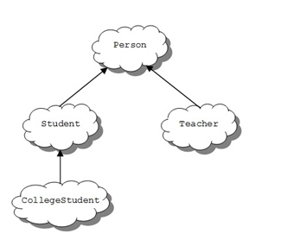
Listed below is the Person base class from the lesson to be used as a starting point for the Teacher class:
class Person {
protected String myName ; // name of the person
protected int myAge; // person’s age
protected String myGender; // “M” for male, “F” for female
public Person(String name, int age, String gender) {
myName = name; myAge = age ; myGender = gender; }
public String toString() {
return myName + “, age: ” + myAge + “, gender: ” +myGender;
}
}
The Student class is derived from the Person class and used as a starting point for the CollegeStudent class:
class Student extends Person {
protected String myIdNum; // Student Id Number
protected double myGPA; // grade point average
public Student(String name, int age, String gender, String idNum, double gpa) {
// use the super class’ constructor
super(name, age, gender);
// initialize what’s new to Student
myIdNum = idNum;
myGPA = gpa;
} }
Assignment:
1. Add methods to “set” and “get” the instance variables in the Person class. These would consist of: getName, getAge, getGender, setName, setAge, and setGender.
2. Add methods to “set” and “get” the instance variables in the Student class. These would consist of: getIdNum, getGPA, setIdNum, and setGPA.
3. Write a Teacher class that extends the parent class Person.
a. Add instance variables to the class for subject (e.g. “Computer Science”, “Chemistry”,, “English”, “Other”) andsalary (the teachers annual salary). Subject should be of type String and salary of type double. Choose appropriate names for the instance variables.
b. Write a constructor for the Teacher class. The constructor will use five parameters to initialize myName, myAge, myGender, subject, and salary. Use the super reference to use the constructor in the Person superclass to initialize the inherited values.
c. Write “setter” and “getter” methods for all of the class variables. For the Teacher class they would be: getSubject, getSalary, setSubject, and setSalary.
d. Write the toString() method for the Teacher class. Use a super reference to do the things already done by the superclass.
4. Write a CollegeStudent subclass that extends the Student class.
a. Add instance variables to the class for major (e.g. “Electrical Engineering”, “Communications”, “Undeclared”) and year (e.g. FROSH = 1, SOPH = 2, …). Major should be of type String and year of type int. Choose appropriate names for the instance variables.
b. Write a constructor for the CollegeStudent class. The constructor will use seven parameters to initialize myName, myAge, myGender, myIdNum, myGPA, year, and major. Use the super reference to use the constructor in the Student superclass to initialize the inherited values.
c. Write “setter” and “getter” methods for all of the class variables. For the CollegeStudent class they would be: getYear, getMajor, setYear, and setMajor.
d. Write the toString() method for the CollegeStudent class. Use a super reference to do the things already done by the superclass.
5. Write a testing class with a main() that constructs all of the classes (Person, Student, Teacher, and CollegeStudent) and calls their toString() method. Sample usage would be:
Person bob = new Person(“Coach Bob”, 27, “M”);
System.out.println(bob);
Student lynne = new Student(“Lynne Brooke”, 16, “F”, “HS95129″, 3.5);
System.out.println(lynne);
Teacher mrJava = new Teacher(“Duke Java”, 34, “M”, “Computer Science”, 50000);|
System.out.println(mrJava);
CollegeStudent ima = new CollegeStudent(“Ima Frosh”, 18, “F”, “UCB123″, 4.0, 1, “English”);
System.out.println(ima);
Question 3.
Polymorphism is very powerful in OOP to separate the interface and implementation so as to allow the programmer to program at the interface in the design of a complex system.
Consider the following example,
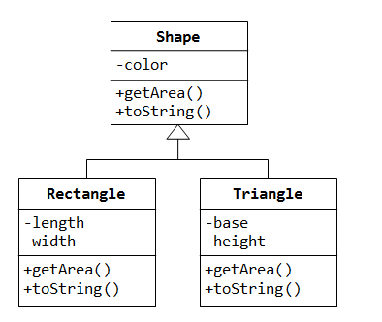
Our program uses many kinds of shapes, such as triangle, rectangle and so on. You should design a super class called Shape, which defines the public interface (or behaviours) of all the shapes as mentioned in the above class diagram. And, we would like all the shapes to have a method called getArea(), which returns the area of that particular shape. Define a Shape class as mentioned in the above class diagram.
public class Shape {
// Instance variable color
// create a constructor for Shape with given color
// write toString() to print the Shape of color
// All shapes must has a method called getArea(), write an abstract method getArea.
}
Then you can then derive subclasses, such as Triangle and Rectangle, from the super class Shape. (Refer the above class diagram)
public class Rectangle extends Shape {
// Instance variables

// Create a constructor with given color, length & width
// call super class constructor Shape(color)
// Override toString() to return the length, width of the Rectangle object and also call super.toString()
to print the color of the Rectangle.
// Override getArea() and provide implementations for calculating the area of the Rectangle…
}
public class Triangle extends Shape {
// Instance variables
// Create a constructor with given color, base & height
// call super class constructor Shape(color)
// Override toString() to return the base, height of the Triangle object and also call super.toString()
to print the color of the Triangle.
// Override getArea() and provide implementations for calculating the area of the Triangle… use the formula (0.5*base*height)
}
The subclasses override the getArea() method inherited from the super class, and provide the proper implementations for getArea().
Finally, create a TestShape class in our application, then create references of Shape, and assign them instances of subclasses. And call the getArea() methods of Rectangle & Triangle by invoking Shape references.
public class TestShape {
public static void main(String[] args) {

//Shape s1, s2;
// System.out.println(s1); calls toString()…
// System.out.println("Area is " + s1.getArea());
// System.out.println(s2); calls toString()…
// System.out.println("Area is " + s2.getArea());
}
}
Note:
- The beauty of this code is that all the references are from the super class (i.e., programming at the interface level). You could instantiate different subclass instance, and the code still works. You could extend your program easily by adding in more subclasses, such as Circle, Square, etc, with ease.
Nonetheless, the above definition of Shape class poses a problem, if someone instantiate a Shape object and invoke the getArea() from the Shape object, the program breaks.
public class TestShape {
public static void main(String[] args) {
// Constructing a Shape instance poses problem!
Shape s3 = new Shape("green");
System.out.println(s3);
System.out.println("Area is " + s3.getArea());
}
}
This is because the Shape class is meant to provide a common interface to all its subclasses, which are supposed to provide the actual implementation. We do not want anyone to instantiate a Shape instance. This problem can be resolved by using the so-called abstract class.

Question 4.

Our application involves many objects that can move. You can define an interface called movable,
containing the signatures of the various movement methods. So define the following abstract methods
to be implemented by the subclasses
moveUp(), moveDown(), moveLeft(), moveRight() & moveUp()
Derive a subclass called MovablePointand provide implementation to all the abstract methods declared in the interface.
public class MovablePoint………………………………… {
// Instance variables - (x, y) coordinates of the point
// create a constructor with given x and y

// Override toString() to return the point at x & y
// Implement all abstract methods defined in the interface Movable
// @Override moveUp (use post decrement operator in the y axis (y--)
// @Override moveDown (use post increment operator in the y axis (y++)
// @Override moveLeft (use post decrement operator in the x axis (x--)
// @Override moveRight (use post increment operator in the x axis (x++)
Now, write a class called TestMovable and up cast sub class instances to the Movable interface, via polymorphism, similar to an abstractclass. And invoke all the interface methods.
public class TestMovable {
public static void main(String[] args) {
// System.out.println(m1); // calls toString()
// m1.moveDown();
// System.out.println(m1); // calls toString()
// m1.moveRight();
// System.out.println(m1); // calls toString()
}
}

Question 5.
Problem Description:
How to use method overloading for printing different types of array? Write a program and use overloaded methods for printing different types of array (integer, double and character).

